Name | Michael D. George
DPG Group and Facilitator | 2016 Spring HRP Manchester / Karen Eccles
CIPD Member | 45761265
Submitted | Tuesday, 31 May 2016
Word Count | 558/600

GDP Absence Analysis
In an effort to understand potential trends at work behind the absence statistics – I will begin by calculating the number of instances per group. For the purposes of clarity, I will combine flu with cold, stress with mood, and physical injuries in three columns. If a figure cannot be averaged against the other groups, this may lead to investigating repeat offenders. Each group is made up of seven employees and all perform the same role.

Group | Flu / Cold | Stress / Mood | Physical Injury / Etc.
A | 27 | - | 12
B | 21 | 11 | 60
C | 48 | 61 | 106

It is clear from the data that Group A is medium for cases of flu and cold, the lowest for stress and mood, and the lowest for physical injury. Group B has the lowest cases of flu and cold, the medium for stress and mood, and medium for physical injury. Group C is the highest for flu and cold, highest for stress and mood, and highest for physical injury.

The highest number of days taken for a single absence was from Group C for stress-related reasons. The most numerous instances per absence are flu/cold. The personal injury makes up the highest total number of absences, with flu/cold as the medium, and stress/mood as lowest. The length of personal injury is understandable in cases of fractures, but consideration to retraining on the return should be looked at. The fact most of these absences are found in Group C is a cause of concern and worth investigating further. If the employee is not able to travel to the office but still able to perform the function, working remotely could maintain output. The data does not show over what timescale these absences were recorded. It is possible the length of time covered is since the beginning of the employee’s tenure.

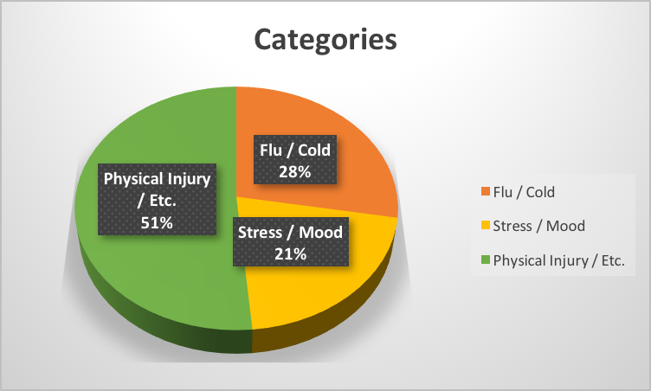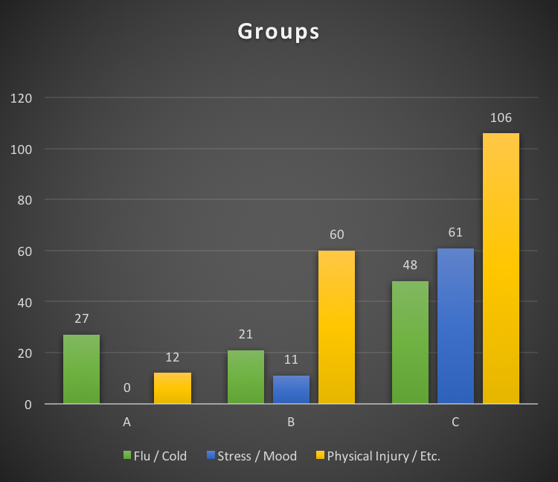

There is a consistent spread of flu/cold cases – with Group C as the majority. Possible causes could be building related (specifically central heating system) or lack of healthy eating options with the canteen menu. Introducing a scheme for free fruit, increasing prices for unhealthy eating options versus healthy may improve overall workplace health. Cases of stress and mood are primarily anxiety based or depressive. Investigating the causes of potential workplace-anxiety may lead to employee workshops, more group discussions, and sponsored community events. Creating awareness of mindfulness techniques and offering a free mental health advice contact number are options worth exploring. Training team leaders to identify signs of mental illness may help detect of an issue before it becomes a problem. Group C reports the highest intake of stress related absence. This could be group-centric or a question of team management. Discovering how each staff member is managed on absence will show whether the policy needs to be reformed or whether it is not being enforced by the team leader. Standardising the policy to account for one absence as the informal warning, two as recorded discussion, and three as HR meeting or intervention.

Group A reports zero instances of absence for stress or mood related reasons. Observation of group dynamic and this particular team leader could provide insight. Group A also logs the lowest number of physical alignments. May indicate good team culture that can be replicated across other teams. Sanctioning ergonomic workplace practices could mitigate the risk of potential injury.

GDP Recommendations Table
GDP Recommendations | What Specific Actions? | Who is Responsible? | Resources Required? | What Are the Timescales? | Business Outcome?
Investigate staff who have taken more than three days absence | Formal action, Recorded Discussions, Warnings | Group Team Leader | Forms, HR advice | One week | Reduced instances of absence
Simplify the means of capturing reasons for absence | Consolidate number of absence reasons with option for more detail | IT | IT and HR advice | Two weeks | Clarity of data and easier to measure against other teams
Six monthly workplace health checks | Conduct ergonomic workplace habits of staff, and safety | HR, Team Leader | Two dedicated personnel | One month to setup | Reduce risk of work-related physical injuries
Issue formal warnings and invitations for meetings | All members of staff who have taken over 20 days absence for a single instance must be managed | HR, Team Leader | One confidential room, minute taking papers | One month | Tailor assistance to employees who are struggling
Refresh training for team leaders of GDP absence policy | Two day training for all Team Leaders to update knowledge of absence policy | HR | One training room, scheduling, one trainer | Three weeks | Empower team leaders to manage instances of absence before poor habits set in
Contact site manager regarding central heating | Investigate schedule of central heating system and the temperature used | Facilities Team | Access to site | One week | Reduced chance of work-related flu/cold

